**Ohio College Degree Analysis**

**Question 1:**

Does the poverty rate have an impact on the number of degrees earned from 2002-2018 in Ohio?

**Question 2:**

Did Ohio’s unemployment rate have an impact on the number of degrees earned from 2002-2018?

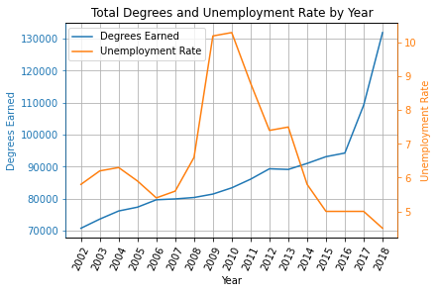

**Question 3:**

Did the median income from 2002-2018 impact the number of degrees obtained?

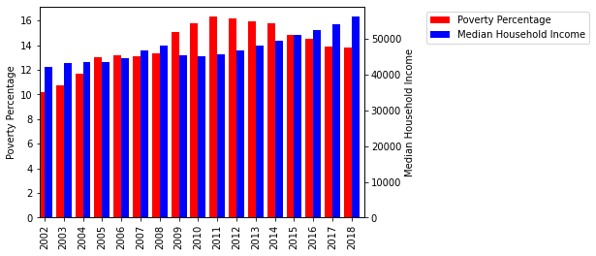

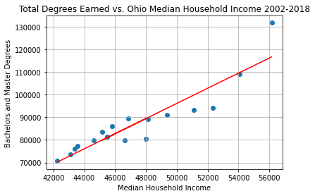

**Question 1 Conclusion:**

Throughout our analysis there seemed to be a slight correlation between the states poverty rate and the number of degrees earned. Perhaps, as poverty rose, less people were attending school. The correlation was calculated at 0.68, again, suggesting a slight correlation.

**Question 2 Conclusion:**

After the analysis was completed, there was no correlation between the unemployment rate and the number of degrees earned. This metric had the lowest correlation of all our calculations. The correlation was calculated at -0.34. Although there looks like there could be a correlation in certain years, the overall data tells a different story.

**Question 3 Conclusion:**

Out of all three degree comparisons, this one was the most surprising. There was a heavy correlation between the median income and the number of degrees earned. The data suggests that the higher the median income the more likely there are going to be college graduates that year. This correlation was calculated at 0.92, the highest correlation out of all analysis.